**LPL TID Letters BOT**

**Task**: To send TID to client, to OSS-Other sides solicitors and to Lender via Hoowla or upload it to Lender exchange/LMS and upload to LMS STARS.

Step 1: Login to Hoowla Portal.

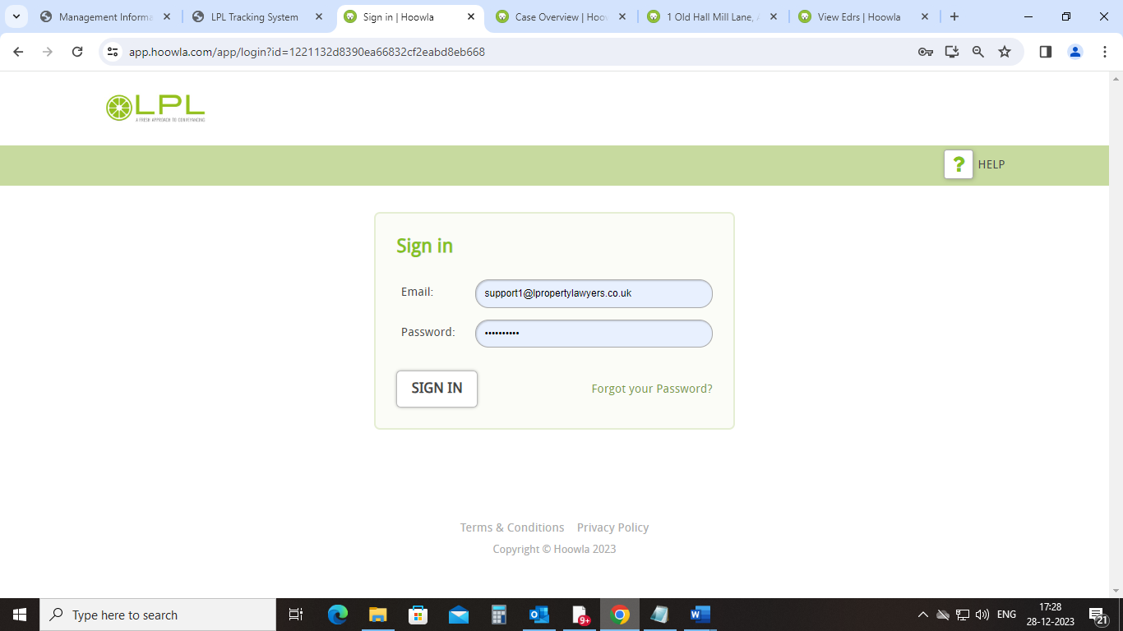

Step 2: Login to “Outsource Post Completion” folder “COR Received”.

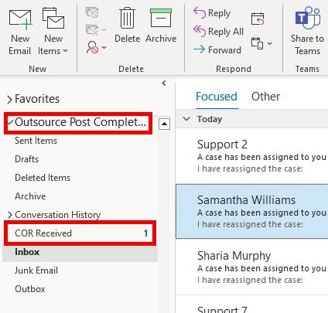

Step 3: BOT will pickup all the unread email and click on “View Requisition”.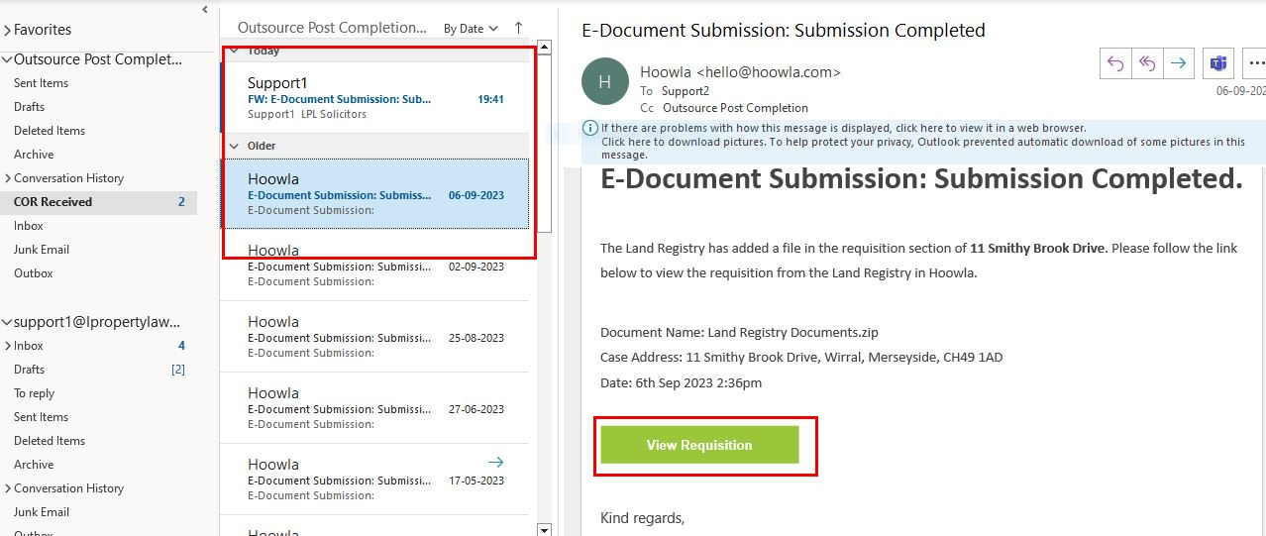

Step 4: Click in between “Cases” and “E-DRS”.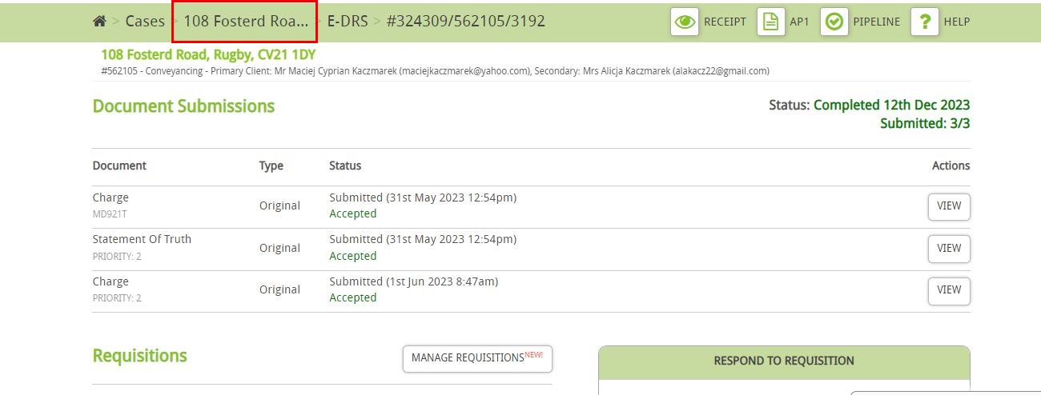

Step 5: Check whether the case is Conveyancing (Remortgage) / Purchase.

Purchase

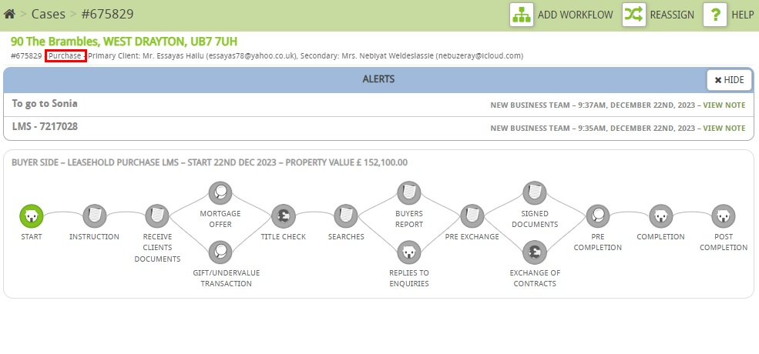

Conveyancing (Remortgage) 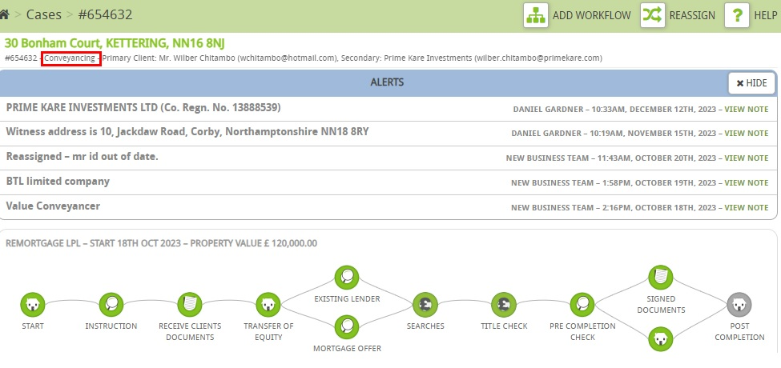Step 6: Click on the Documents.

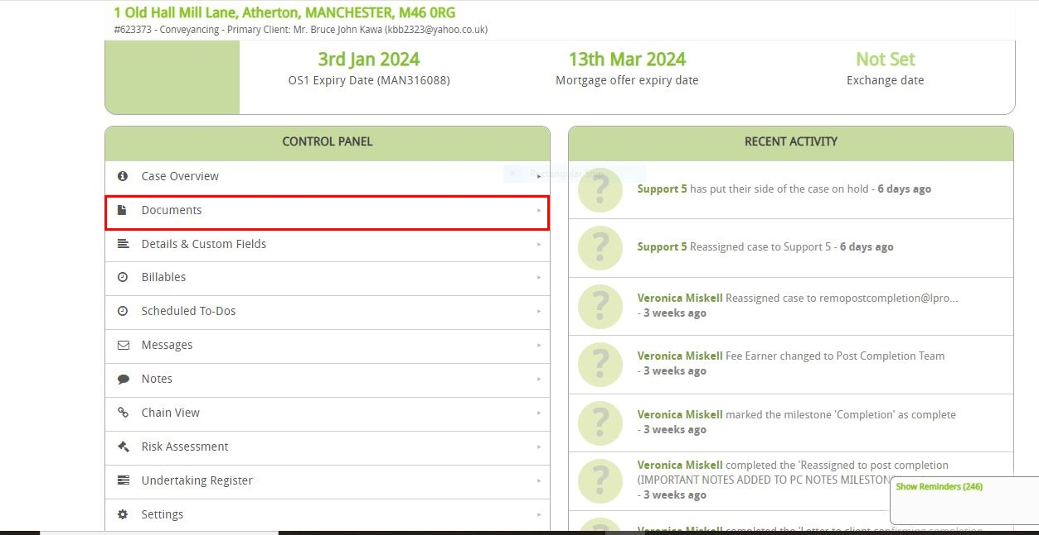

Step 6: Click on “COMPLETION: 2-reg”.

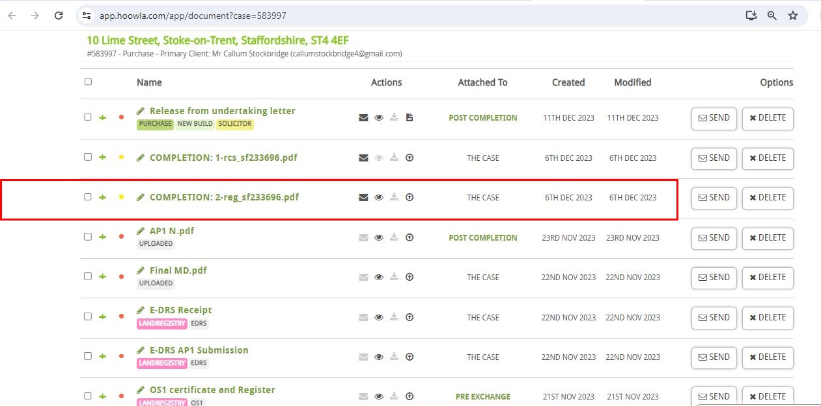

Step 7: Cross check with the property address on COMPLETION: 2-reg.

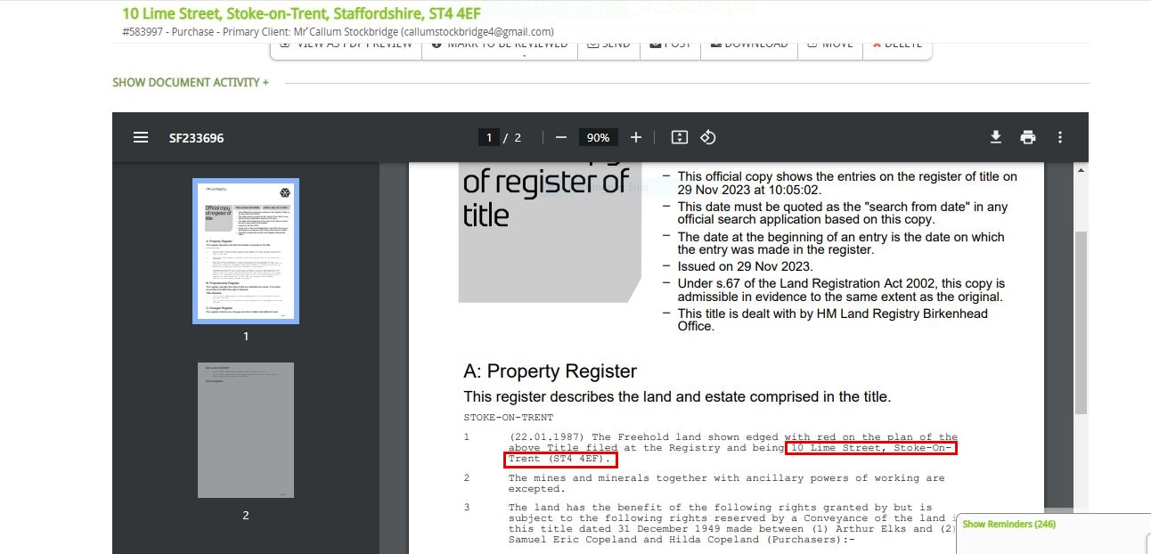

Step 8: Cross check with the client’s name on COMPLETION: 2-reg from E-DRS AP1 Submission.

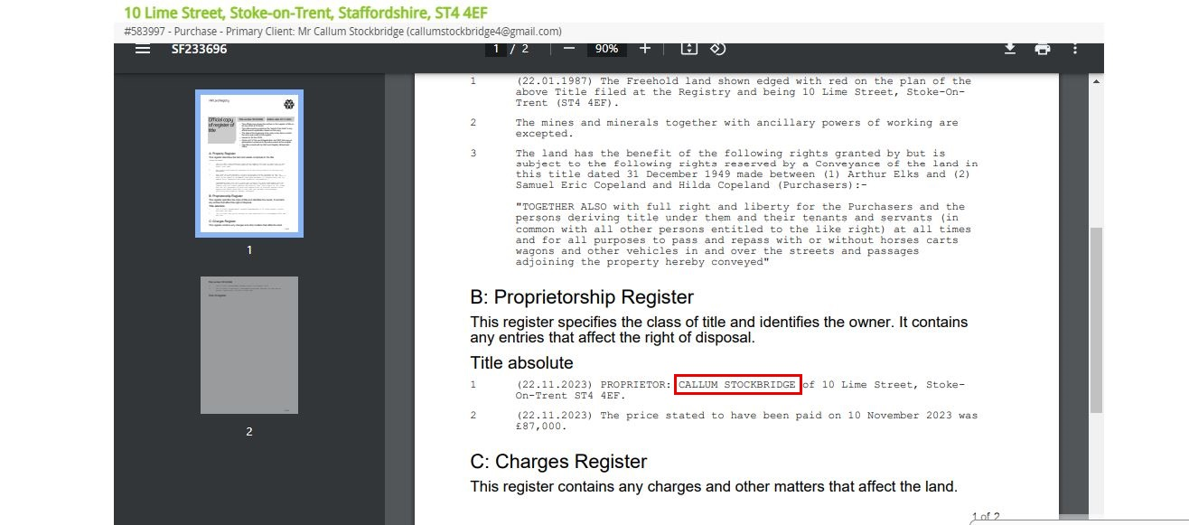

Step 8.1: E-DRS AP1 Submission: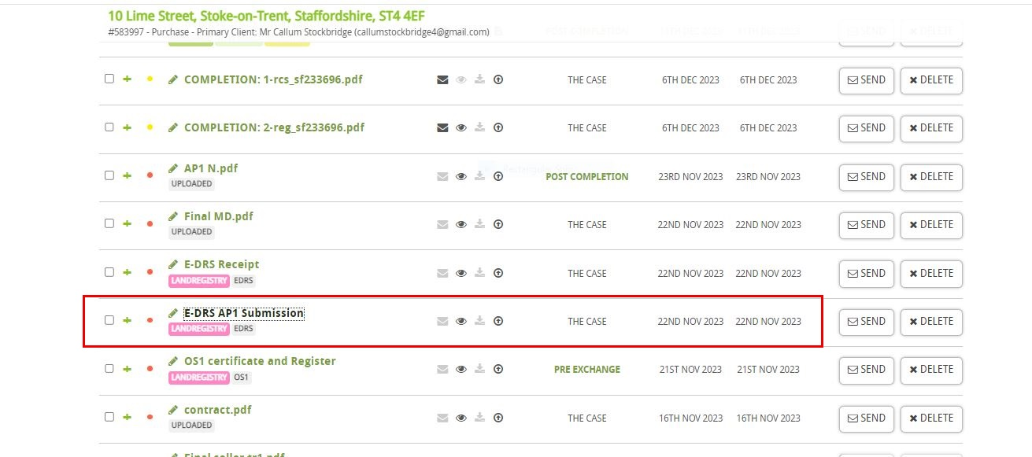

Step 8.2: Cross check client name from E-DRS AP1 Submission: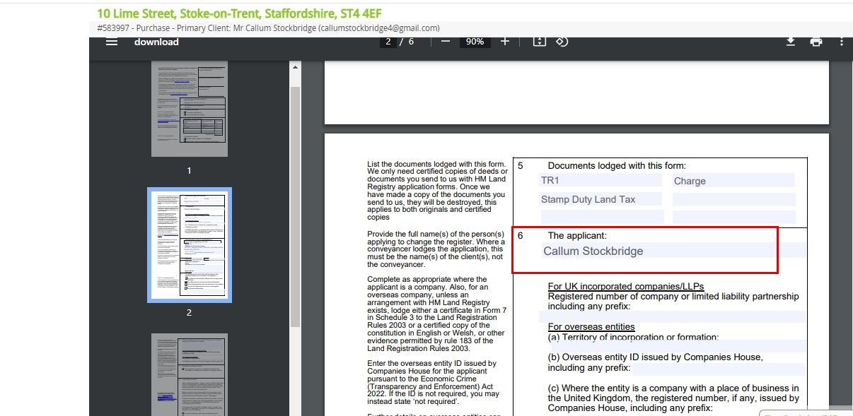

Step 9: Cross check with the property value on COMPLETION: 2-reg from the first page of the case (Purchase case only).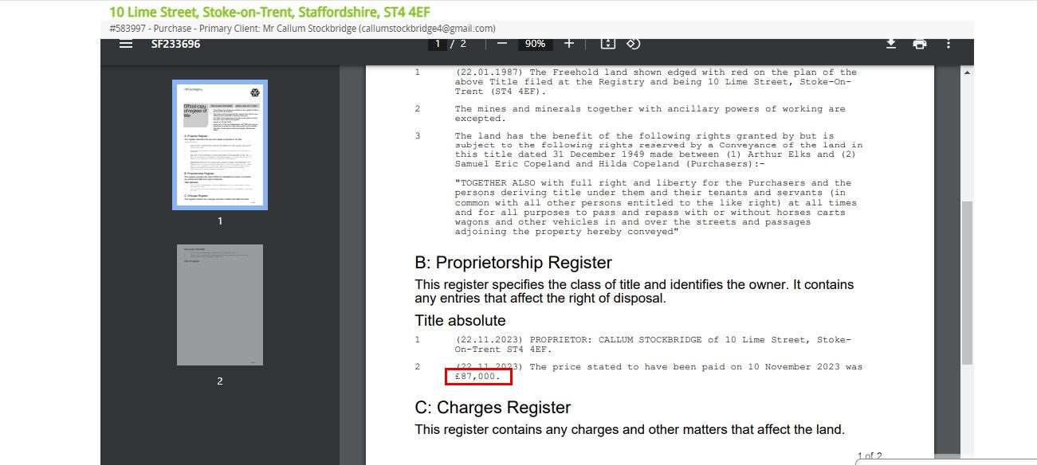

Step 9.1: Cross check the property value.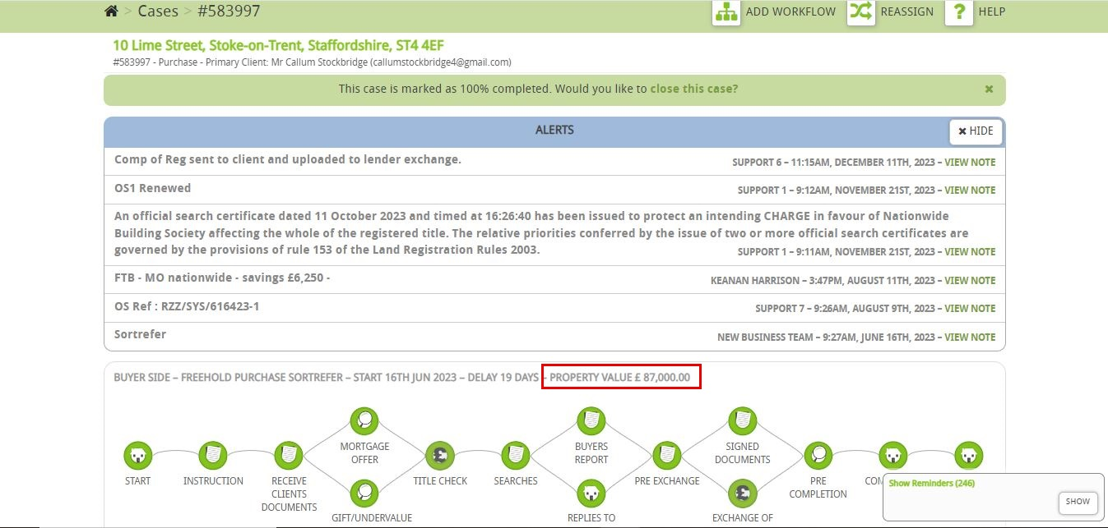

Step 10: If the Unilateral notice is identified in C: Charges Register, this should be Informed to us (No TID should be sent out).

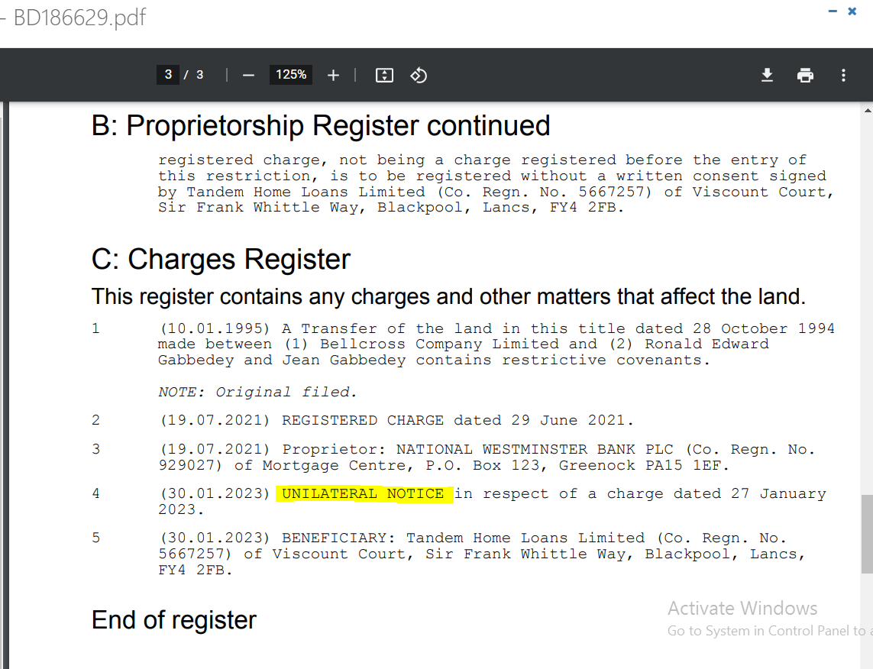

Step 11: Check the lender’s name on COMPLETION: 2-reg- if lender is from Lender exchange/ LMS lender/ Skipton (Remortgage case only)/ Neither from any portal/ If no lender (Just sent it to client). Compare the “Registered Charge dated” from “Completion date”.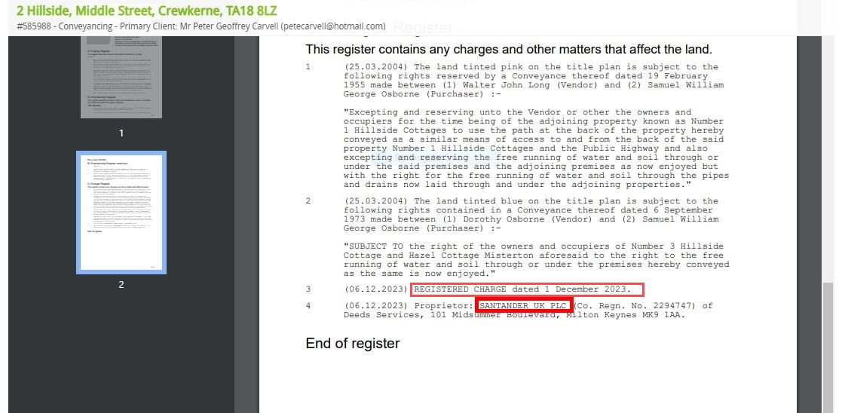

Step 11.A: Completion date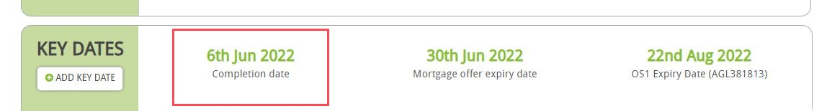

Step 11.B: If two “Registered Charge dated” found on COMPLETION: 2-reg, this should be Informed to us (No TID should be sent out).

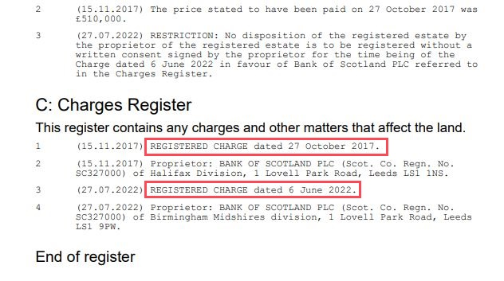

**Step 12: IF Lender Exchange Lender:**

Step 12.1: Click on law firms.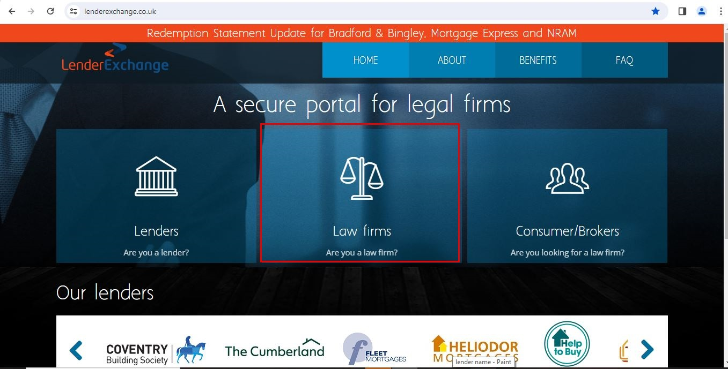

Step 12.2: Login to Lender Exchange Portal.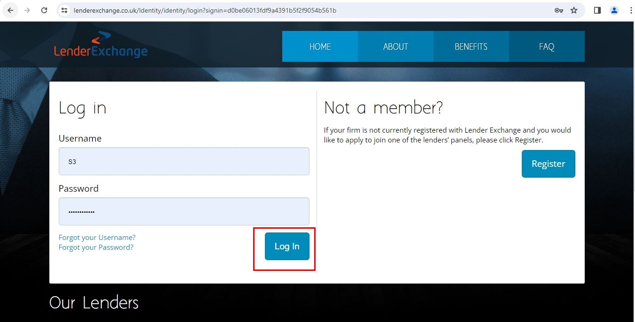

Step 12.3: Click on Transaction Management.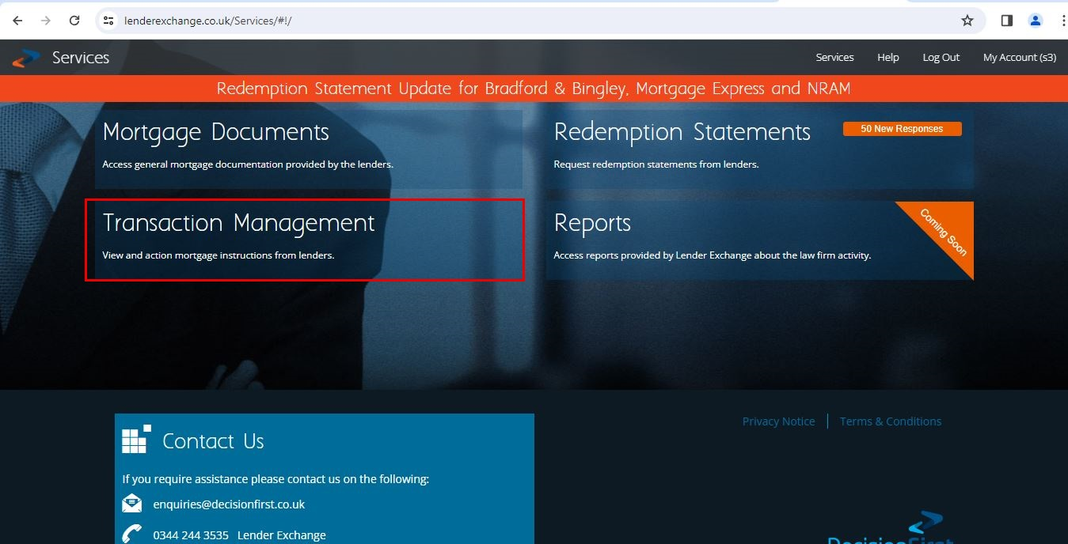

Step 12.4: Search the case on Lender Exchange by using Property postcode.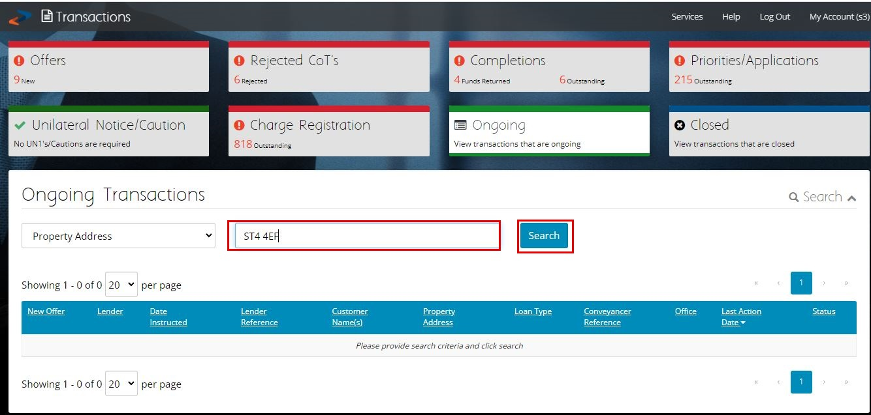

Step 12.5: Click on the case.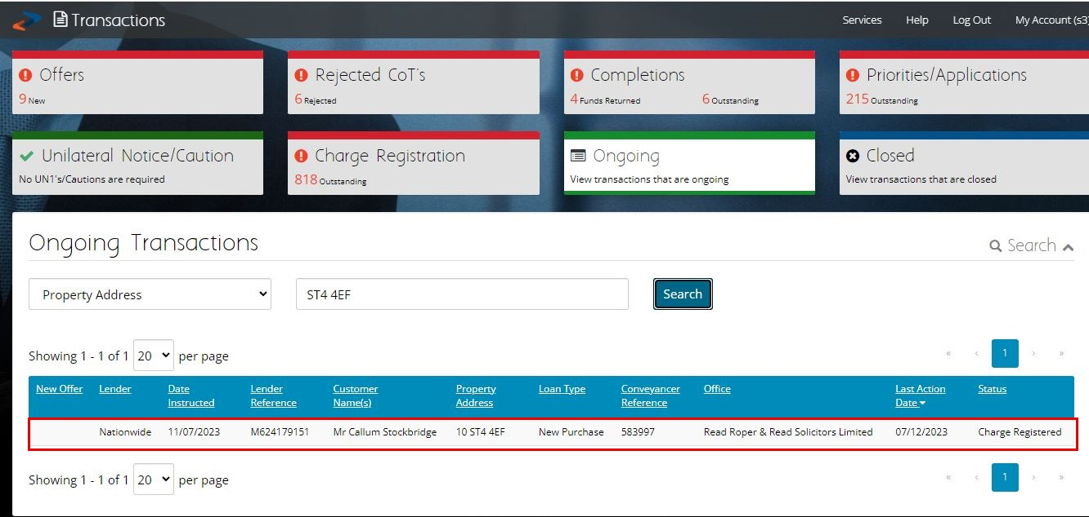

Step 12.6: Cross check the client’s name and property address.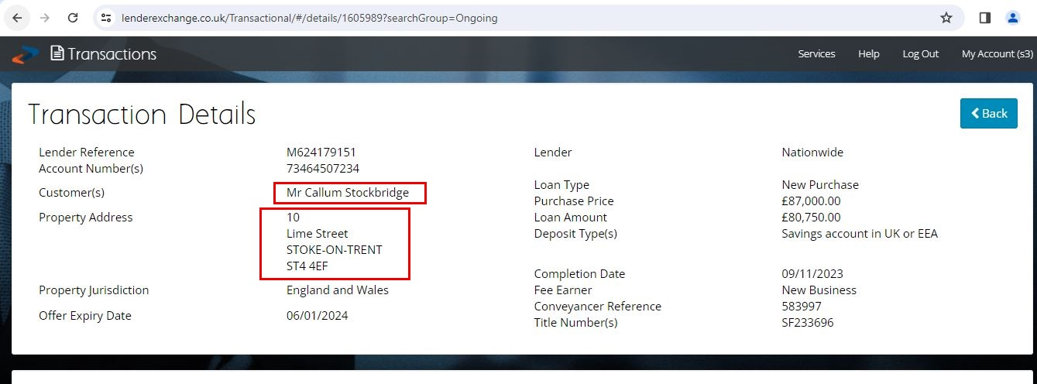

Step 12.7: If “Confirm Charge Registered” option does not enable first upload “Confirm Application”.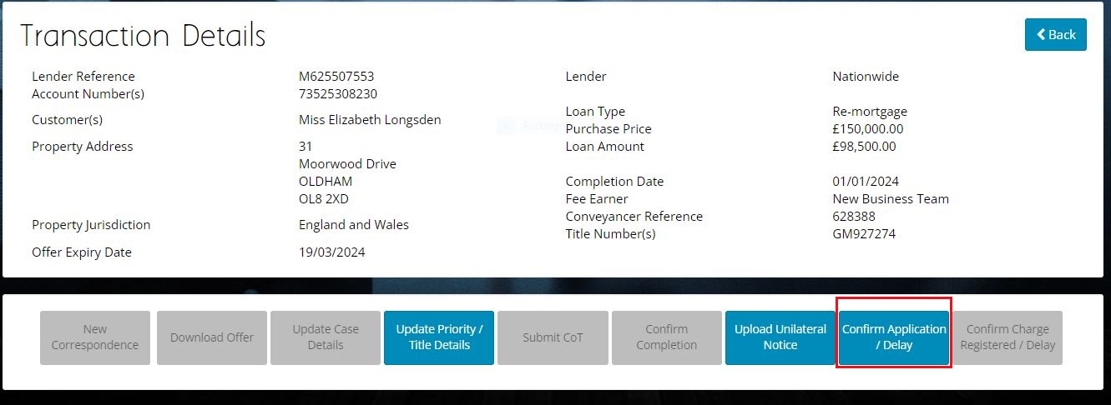

Step 12.8: Click on “Yes” add the date when “E-DRS Receipt” upload the “E-DRS Receipt” then click on “Save”.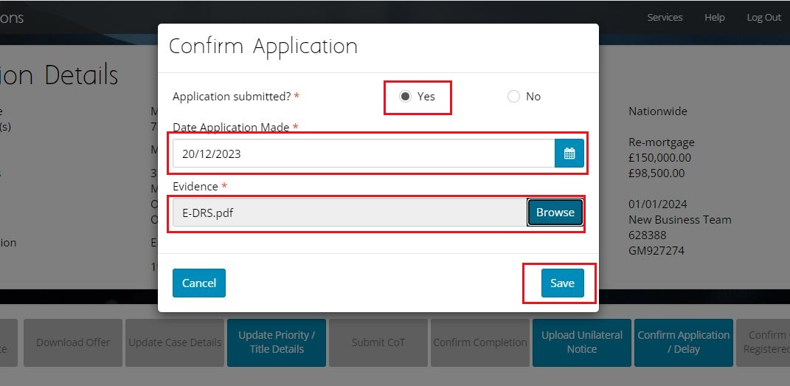

Step 12.8.A: “E-DRS Receipt” and “Date Application Made”.

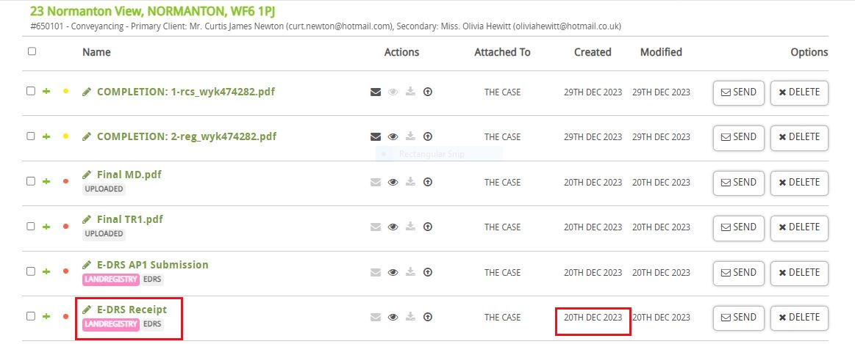

Step 12.9: If “Confirm Charge Registered” enable upload “COMPLETION: 2-reg”.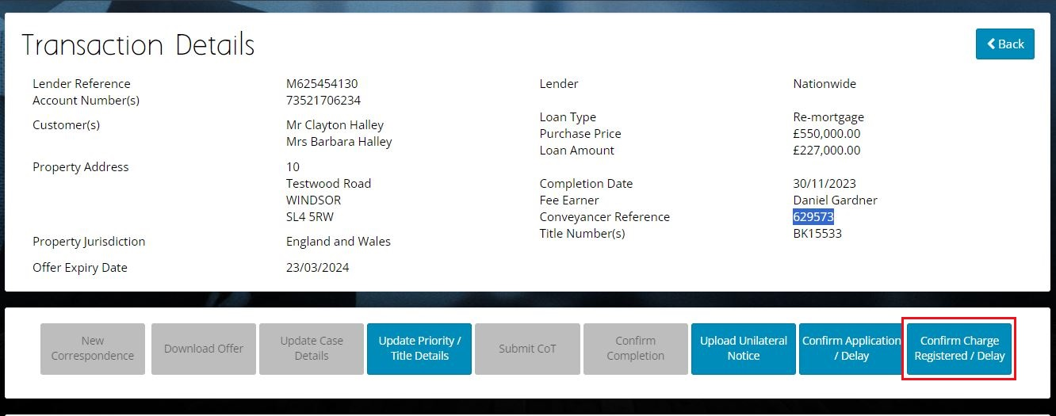

Step 12.10: Click on “Yes” add the date when “COMPLETION: 2-reg” upload the “COMPLETION: 2-reg” then click on “Save”.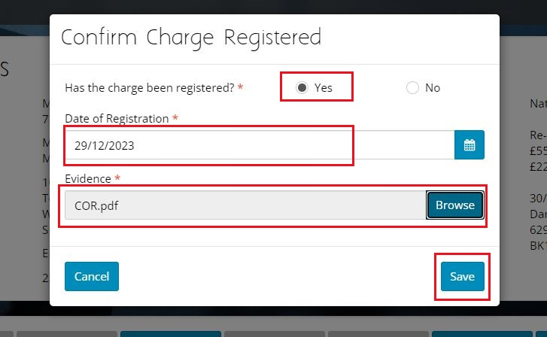

Step 12.10.A: “COMPLETION: 2-reg” and “Date of Registration”.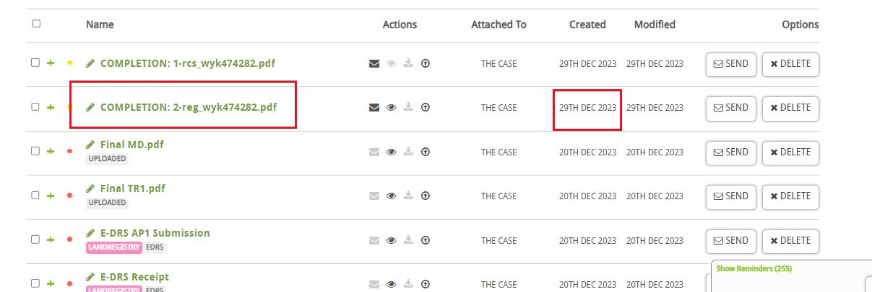

Step 12.11: Click on “Post Completion”.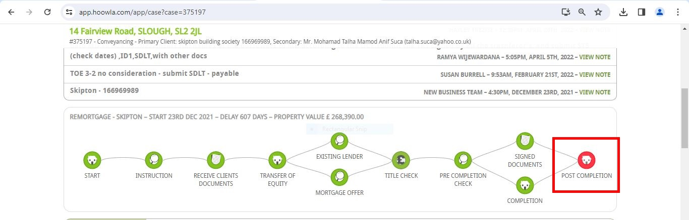

Step 12.12: Click on “Attach Document”.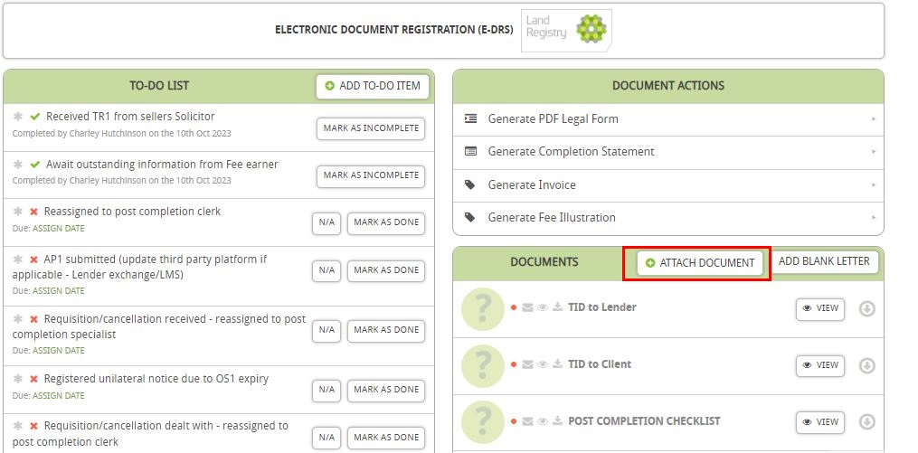

Step 12.13: Search “TID to client” click on “Attach Document”.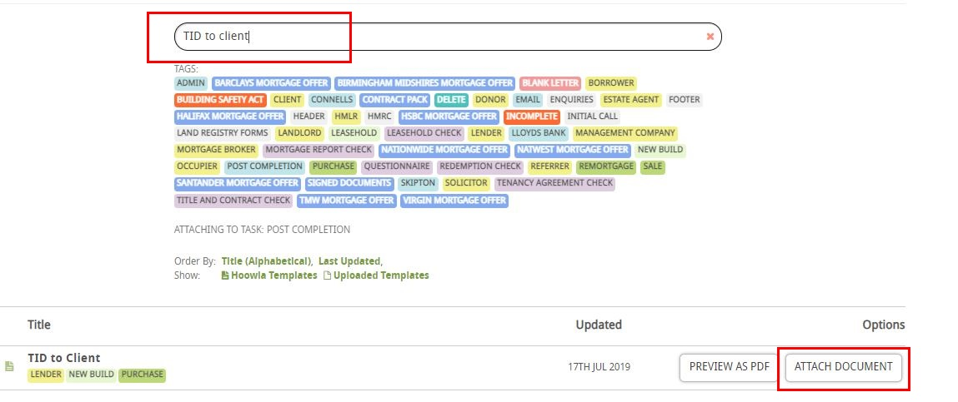

Step 12.14: Cross check the name and address of Client then click on “Send”.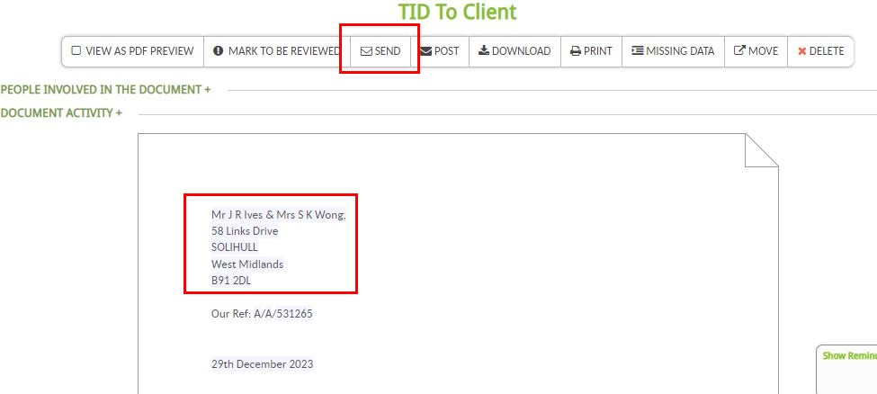

Step 12.15: Click on “Client” in People (there might be multiple clients).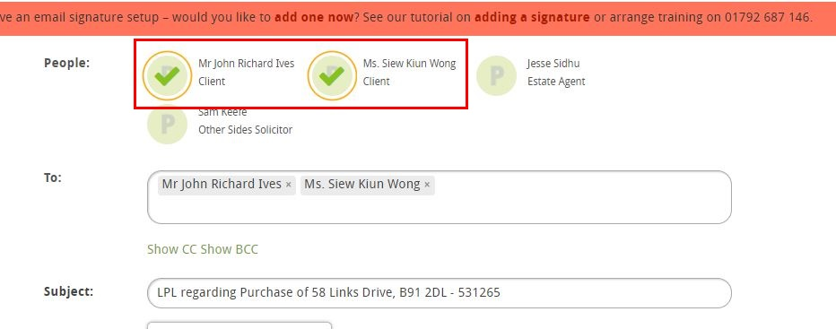

Step 12.16: Click on “Attach Other Documents”.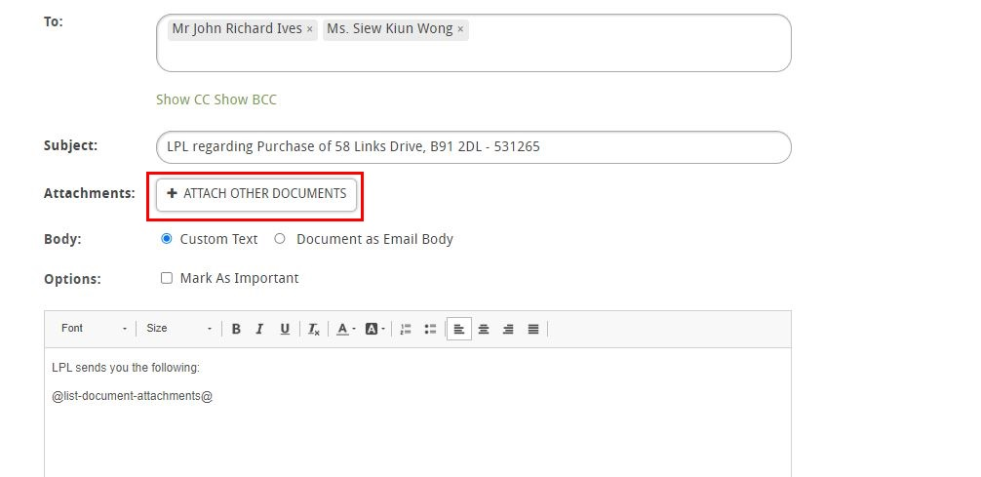

Step 12.17: Search for “COMPLETION:” then tick both the documents.

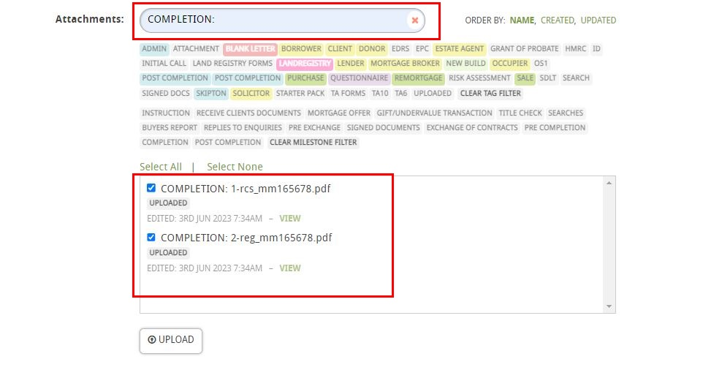

Step 12.18: Click on “Mark as Important” type the body and click on “Send”.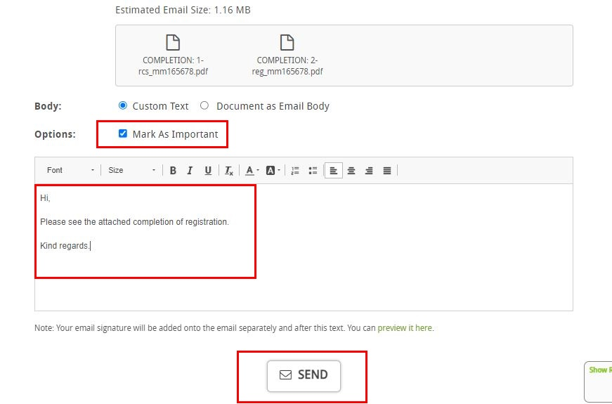

Step 12.19: Click on “Post Completion”.

Step 12.20: Click on “Mark as Done” for “Completed registration received and checked - names and registered charge correct”.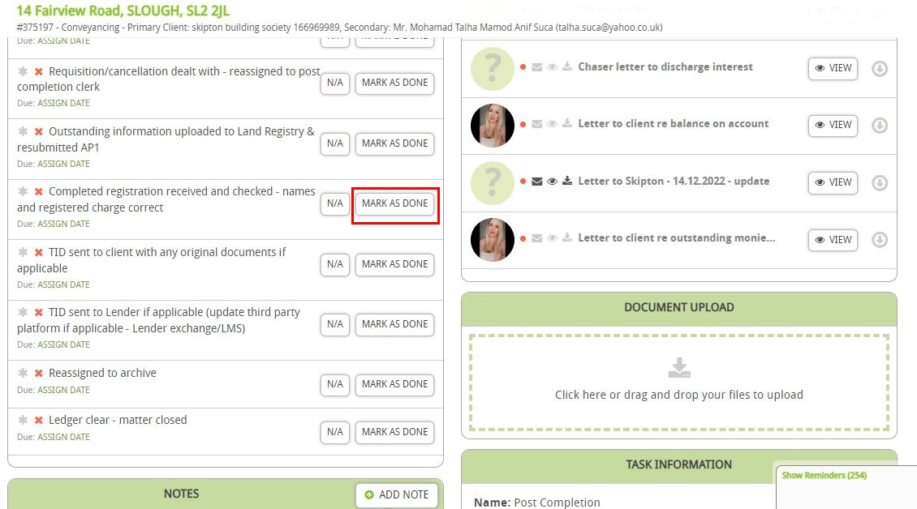

Step 12.21: Click on “Mark as Done” for “TID sent to client with any original documents if applicable”.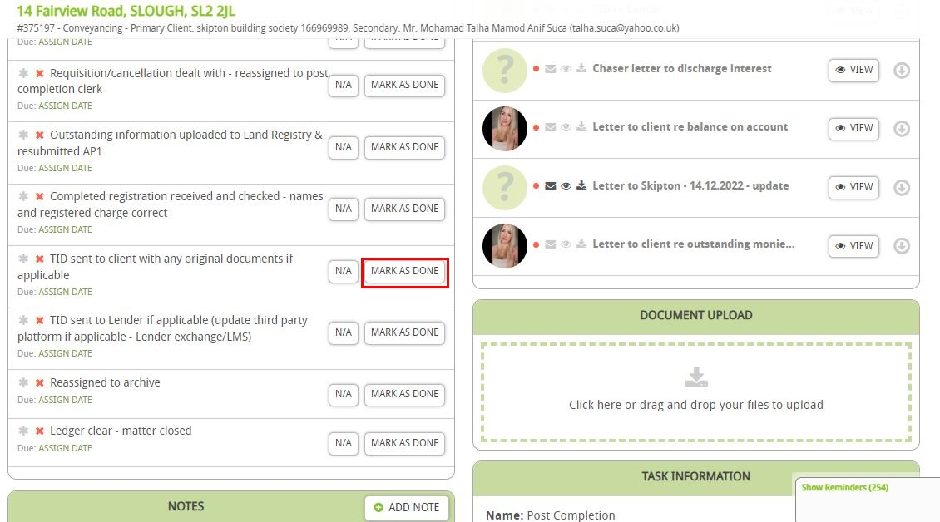

Step 12.22: Click on “Mark as Done” for “TID sent to Lender if applicable (update third party platform if applicable - Lender exchange/LMS)”.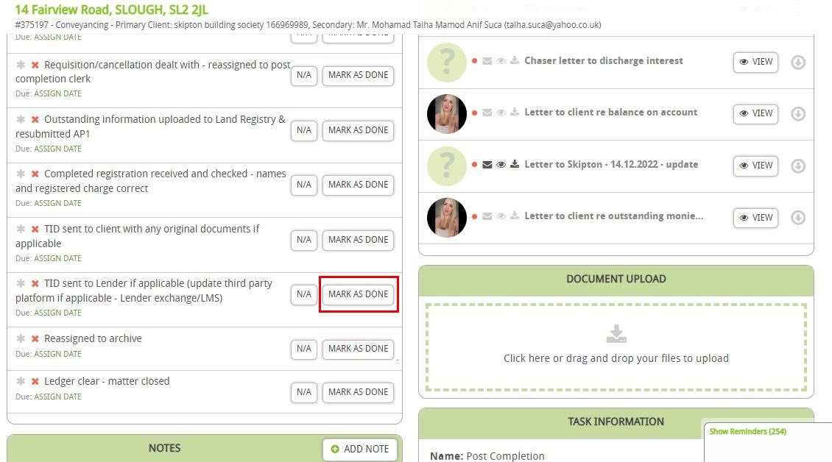

Step 12.23: Click on “Mark as Done” for “Reassigned to archive”.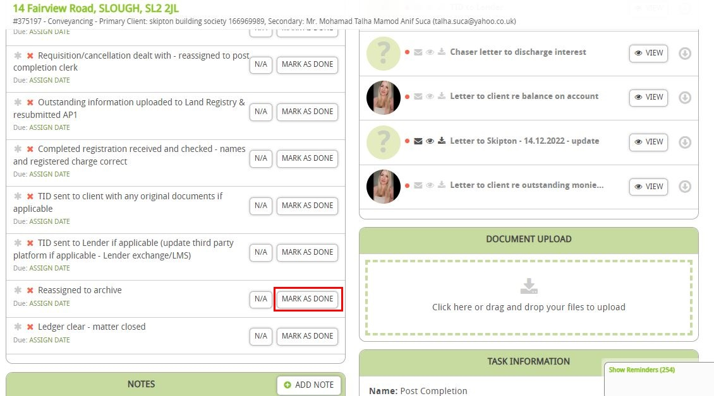

Step 12.24: Click on “Add Note”.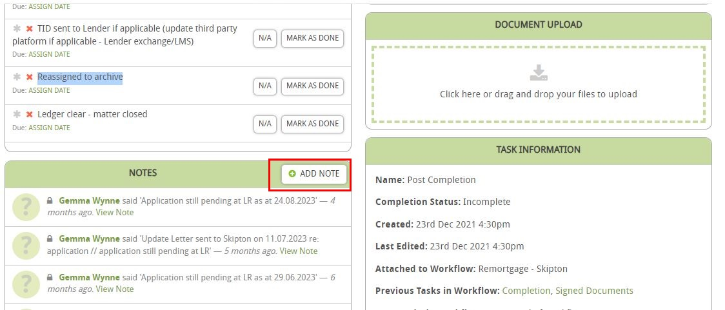

Step 12.25: Click on “Mark as an Important” type the note on “Content” then click on “Save”.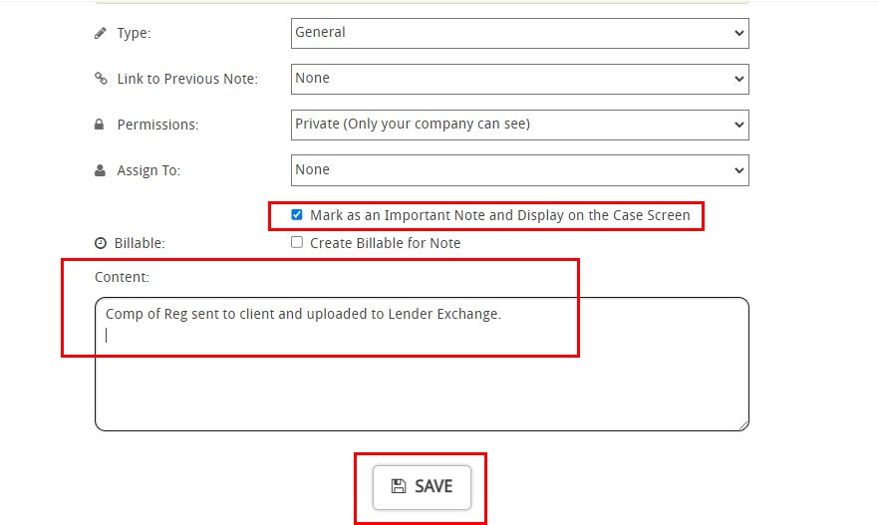

Step 12.26: Click on “Mark as Complete”. 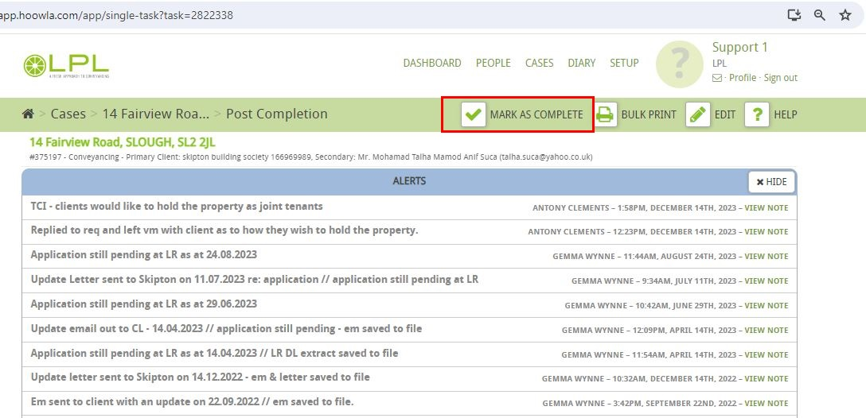

Step 12.27: Click on “OS1 Expiry Date”.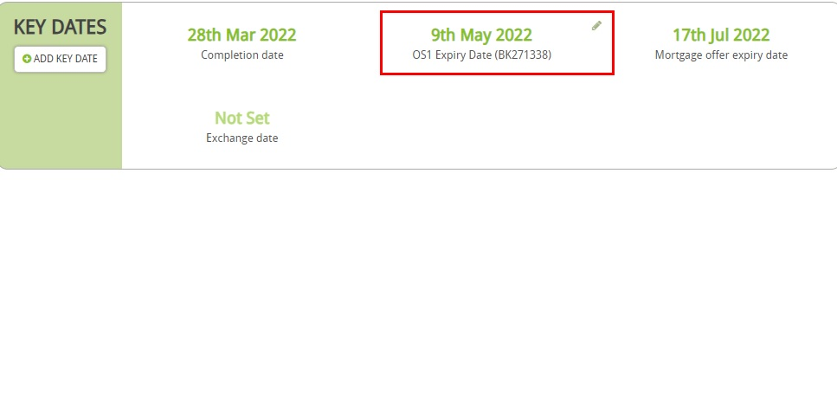Step 12.28: Click on “Clear Date” and then “Save”.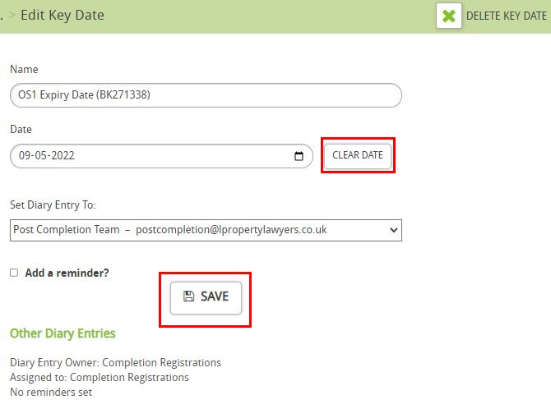

Step 12.29: Click on “Settings”.

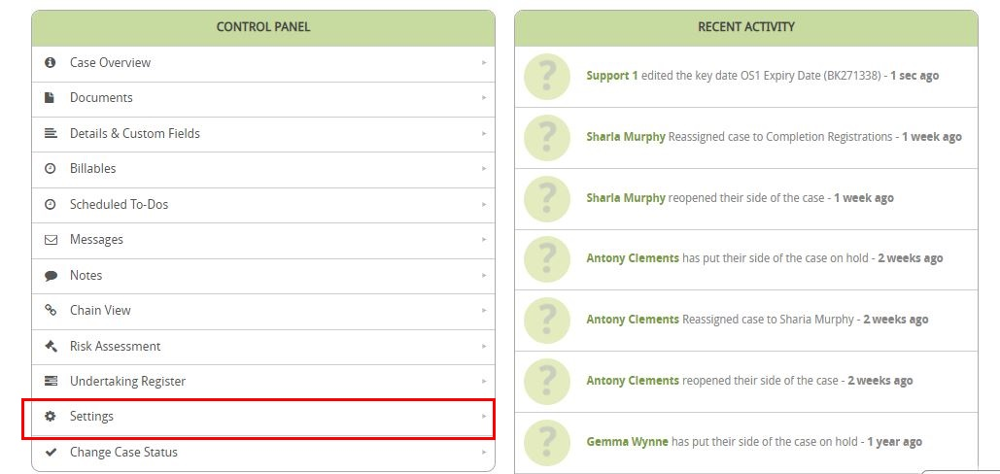

Step 12.30: Come to “Case Details” Change “Fee Earner for case- Archive” and “Case Worker for case- Archive” then click on “Save”.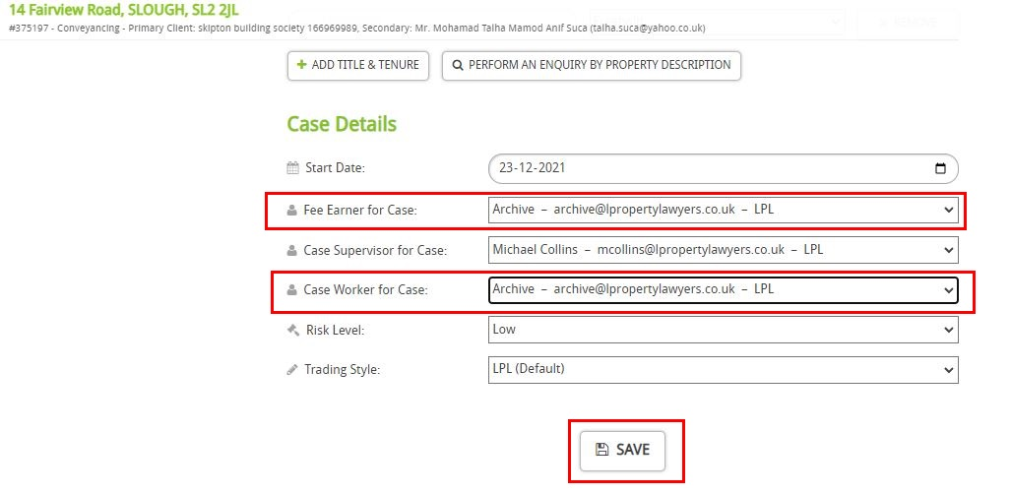

**Step 13: IF LMS Lender:**

Step 13.1: Login to LMS.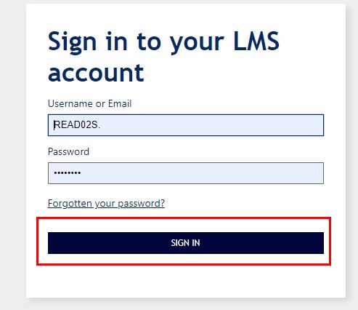

Step 13.2: Click on “Click to search cases” to search the case on LMS.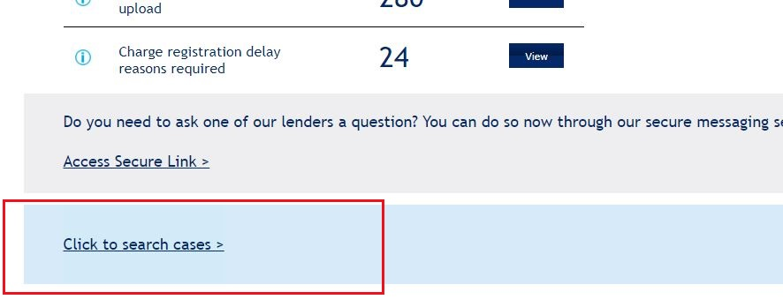

Step 13.3: Select as “Conveyed postcode” type the postcode then click on “Search”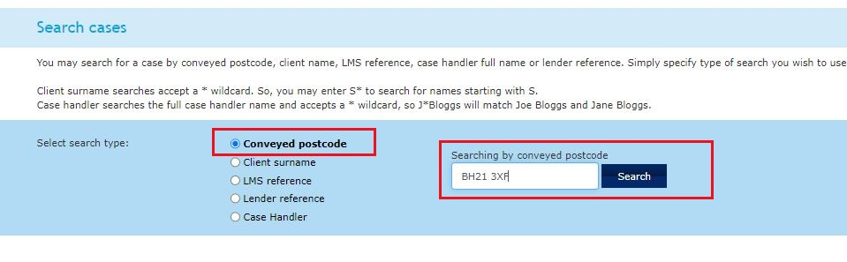

Step 13.4: Crosscheck the “Client name” & “Conveyed Address”.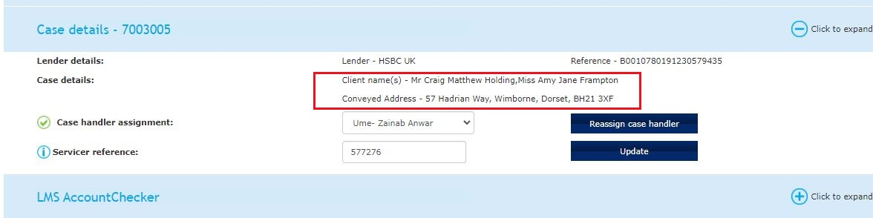

Step 13.5: If “Official Copy Register” option does not enable first upload “Application to Register” upload “E-DRS Receipt” then click on “Upload”.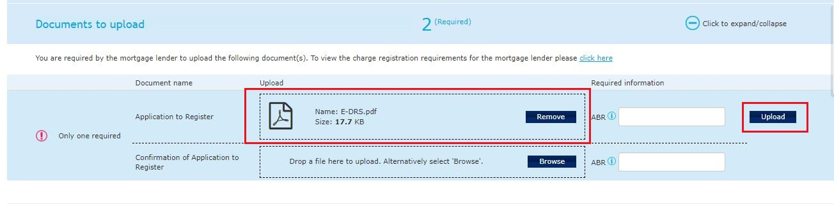

Step 13.6: Upload “COMPLETION: 2-reg” then click on “Upload”.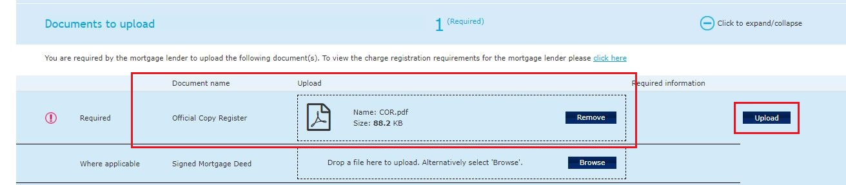

Step 13.7: Click on “Post Completion”.

Step 13.8: Click on “Attach Document”.

Step 13.9: Search “TID to client” click on “Attach Document”.

Step 13.10: Cross check the name and address of Client then click on “Send”.

Step 13.11: Click on “Client” in People (there might be multiple clients).

Step 13.12: Click on “Attach Other Documents”.

Step 13.13: Search for “COMPLETION:” then tick both the documents.



Step 13.14: Click on “Mark as Important” type the body and click on “Send”.

Step 13.15: Click on “Post Completion”.

Step 13.16: Click on “Mark as Done” for “Completed registration received and checked - names and registered charge correct”.

Step 13.17: Click on “Mark as Done” for “TID sent to client with any original documents if applicable”.

Step 13.18: Click on “Mark as Done” for “TID sent to Lender if applicable (update third party platform if applicable - Lender exchange/LMS)”. 

Step 13.19: Click on “Mark as Done” for “Reassigned to archive”.

Step 13.20: Click on “Add Note”.

Step 13.21: Click on “Mark as an Important” type the note on “Content” then click on “Save”.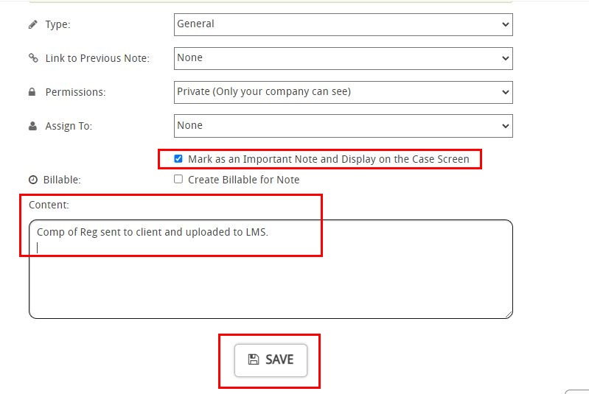

Step 13.22: Click on “Mark as Complete”. 

Step 13.23: Click on “OS1 Expiry Date”.Step 13.24: Click on “Clear Date” and then “Save”.Step 13.25: Click on “Setting”.



Step 13.26: Come to case Details Change “Fee Earner for case- Archive” and “Case Worker for case- Archive” then click on “Save”.

**Step 14: IF Skipton Lender (Remortgage case only):**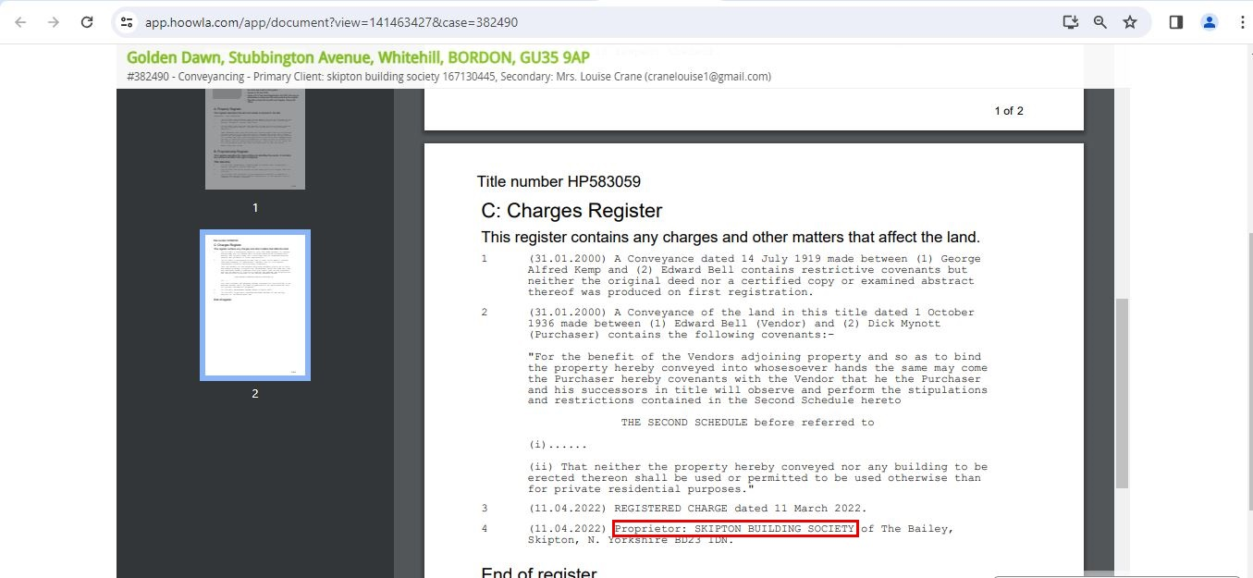

Step 14.1: Go back to the first page of the case in “Messages” of “Control Panel”.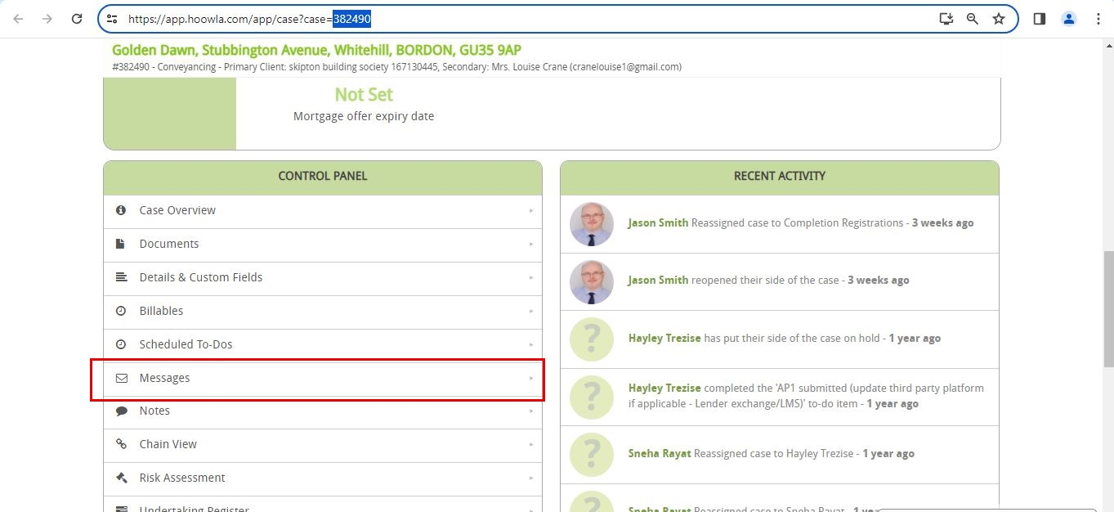

Step 14.2: Click on “New”.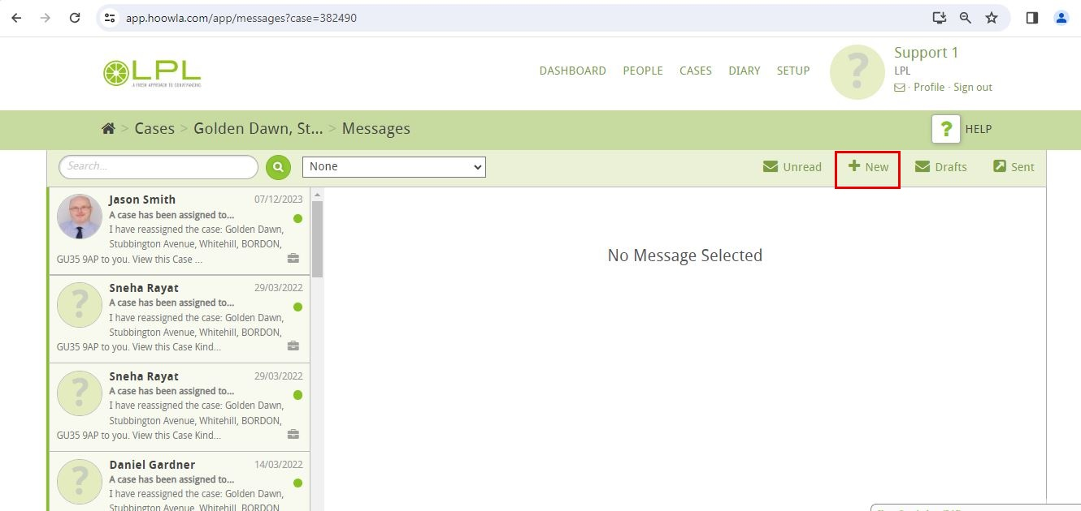

Step 14.3: Enter the email address of Skipton in “TO:” and then click on “+Add Attachments”.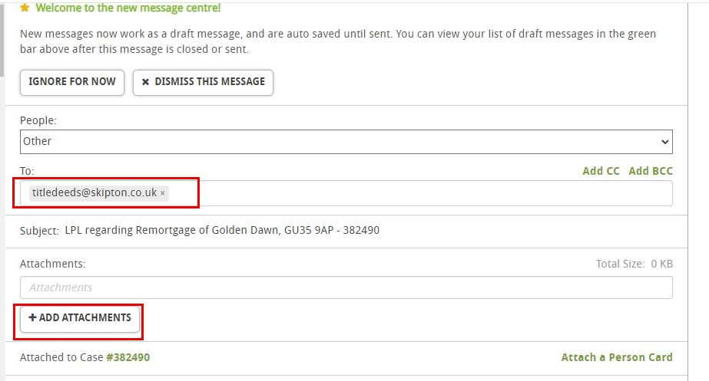

Step 14.4: Select both “COMPLETION: 1 & COMPLETION: 2” documents and then click on “+ADD”.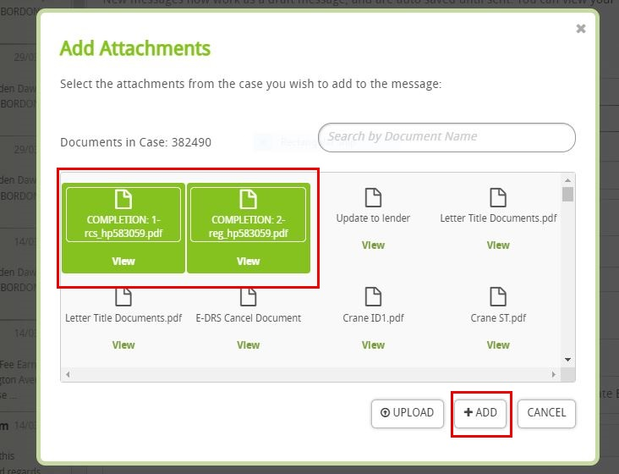

Step 14.5: Click on “Mark Email as Important” type the body and click on “Send”.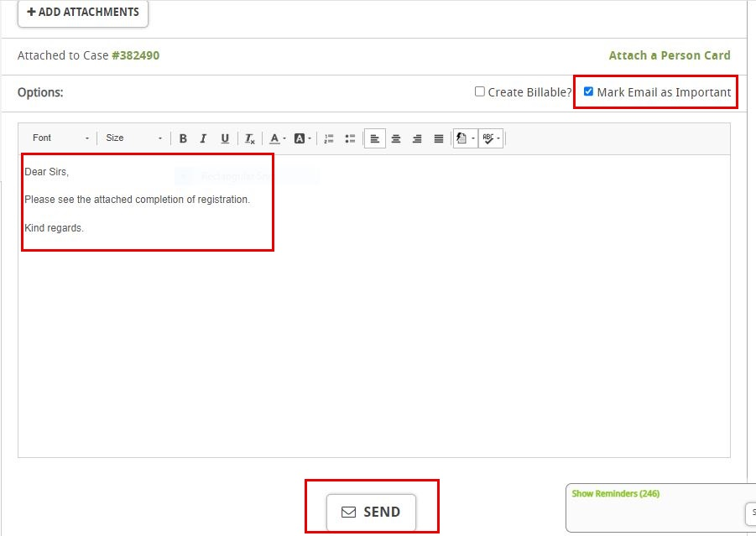

Step 14.6: Click on “Post Completion”.

Step 14.7: Click on “Mark as Done” for “Completed registration received and checked - names and registered charge correct”.

Step 14.8: Click on “Mark as Done” for “TID sent to client with any original documents if applicable”.Step 14.9: Click on “N/A” for “TID sent to Lender if applicable (update third party platform if applicable - Lender exchange/LMS)”.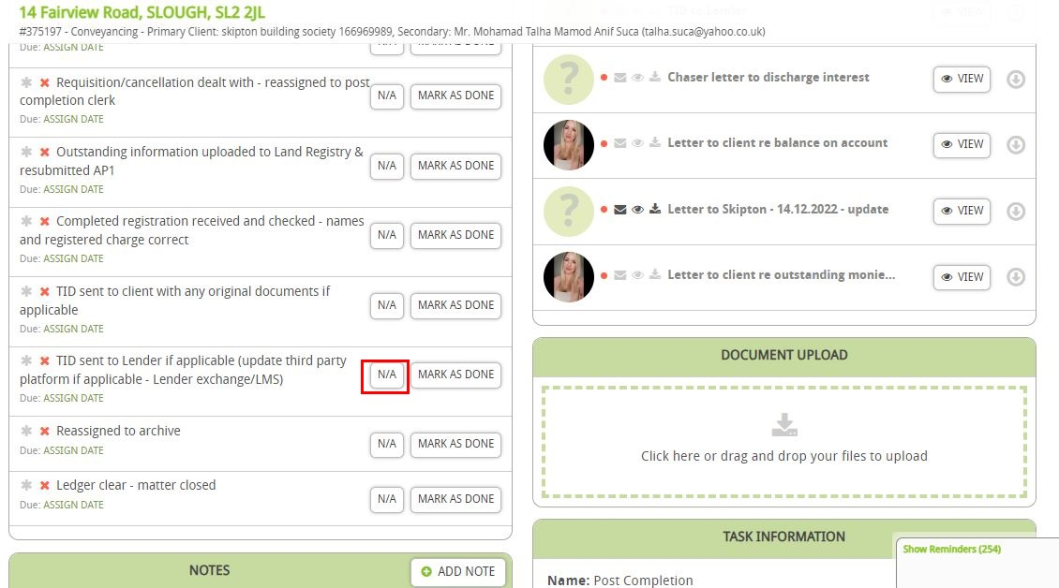

Step 14.10: Click on “Mark as Done” for “Reassigned to archive”.

Step 14.11: Click on “Add Note”.

Step 14.12: Click on “Mark as an Important” type the note on “Content” then click on “Save”.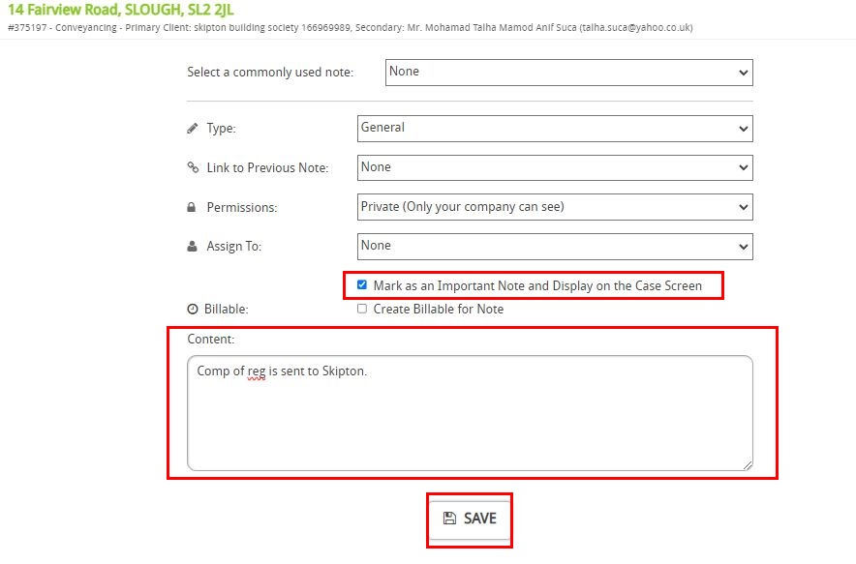

Step 14.13: Click on “Mark as Complete”. 

Step 14.14: Click on “OS1 Expiry Date”.Step 14.15: Click on “Clear Date” and then “Save”.

Step 14.16: Click on “Setting”.



Step 14.17: Come to case Details Change “Fee Earner for case- Archive” and “Case Worker for case- Archive” then click on “Save”.

**Step 15: If no lender (Sent to client only)**.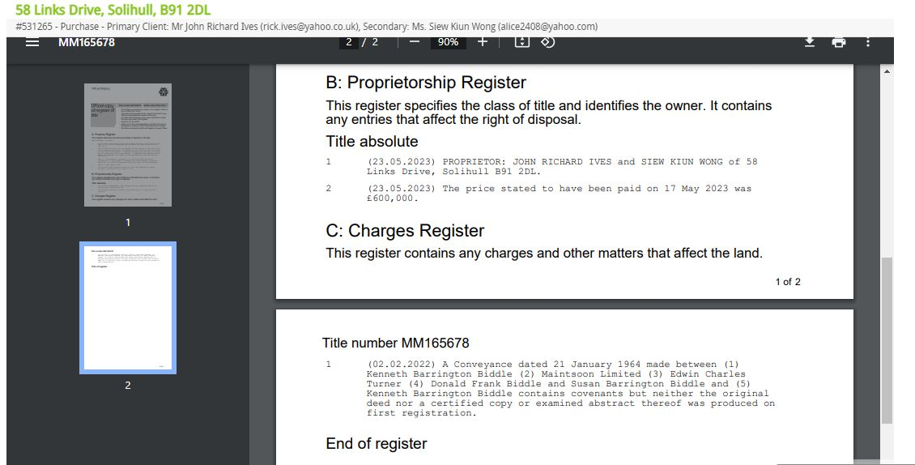

Step 15.1: Click on “Post Completion”.

Step 15.2: Click on “Attach Document”.

Step 15.3: Search “TID to client” click on “Attach Document”.

Step 15.4: Cross check the name and address of Client then click on “Send”.

Step 15.5: Click on “Client” in People (there might be multiple clients).

Step 15.6: Click on “Attach Other Documents”.

Step 15.7: Search for “COMPLETION:” then tick both the documents.



Step 15.8: Click on “Mark as Important” type the body and click on “Send”.

Step 15.9: Click on “Post Completion”.

Step 15.10: Click on “Mark as Done” for “Completed registration received and checked - names and registered charge correct”.

Step 15.11: Click on “Mark as Done” for “TID sent to client with any original documents if applicable”.

Step 15.12: Click on “N/A” for “TID sent to Lender if applicable (update third party platform if applicable - Lender exchange/LMS)”. 

Step 15.13: Click on “Mark as Done” for “Reassigned to archive”.

Step 15.14: Click on “Add Note”.

Step 15.15: Click on “Mark as an Important” type the note on “Content” then click on “Save”.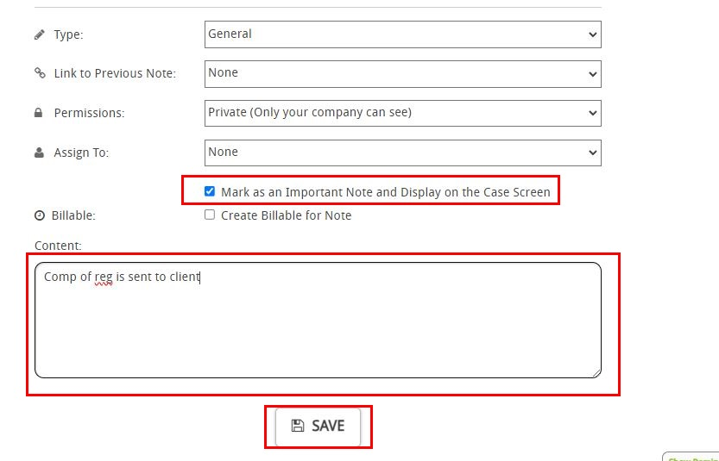

Step 15.16: Click on “Mark as Complete”. 

Step 15.17: Click on “OS1 Expiry Date”.

Step 15.18: Click on “Clear Date” and then “Save”.

Step 15.19: Click on “Setting”.



Step 15.20: Come to case Details Change “Fee Earner for case- Archive” and “Case Worker for case- Archive” then click on “Save”.

**Step 16: If Lender neither from any portal (Sent to Lender via Hoowla)**.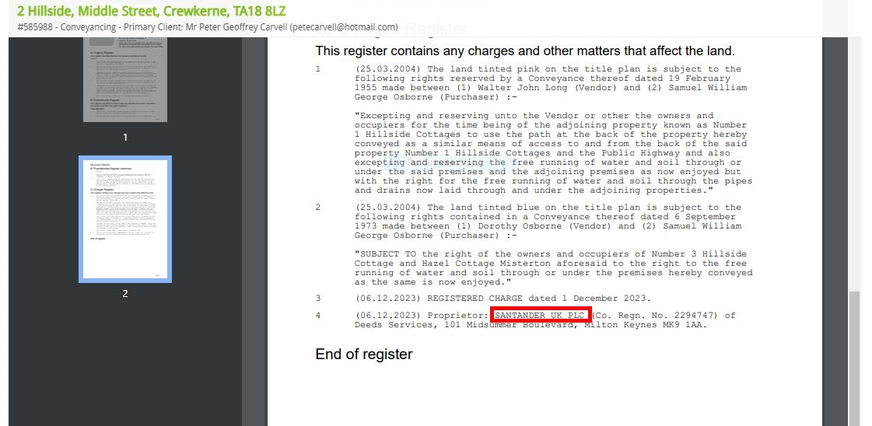

Step 16.1: Click on “Post Completion”.

Step 16.2: Click on “Attach Document”.

Step 16.3.A: Search “TID to Lender” for **Purchase case** only click on “Attach Document”.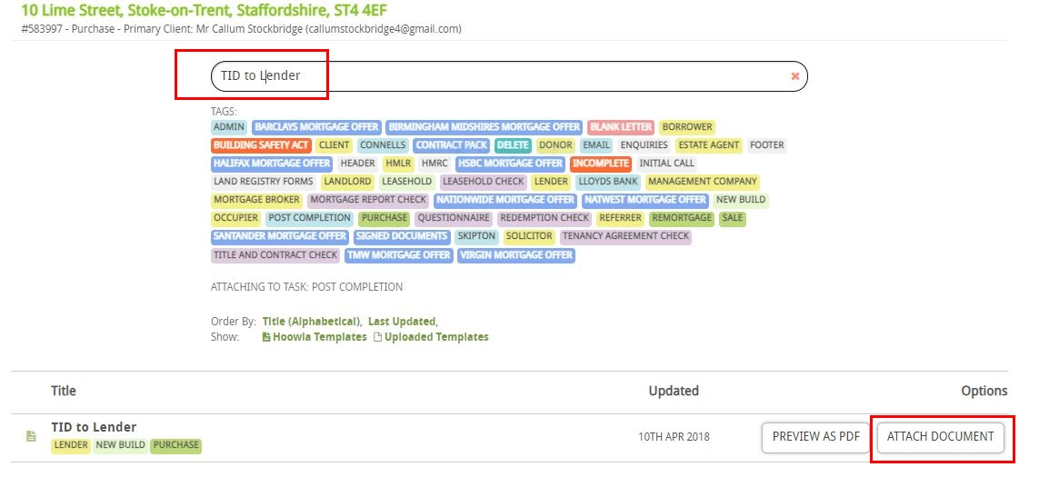

Step 16.3.B: Search “TID to Lender (R)” for **Conveyancing (Remortgage) case** only click on “Attach Document”.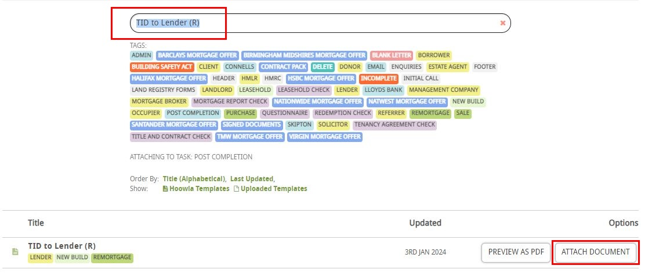

Step 16.4: Cross check the name and address of Lender then click on “Send”.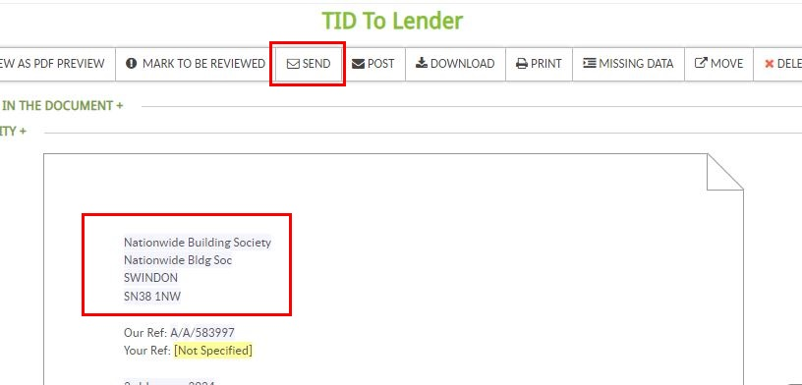

Step 16.5.A: Click on “New Lender” in People for “Conveyancing (Remortgage) case”.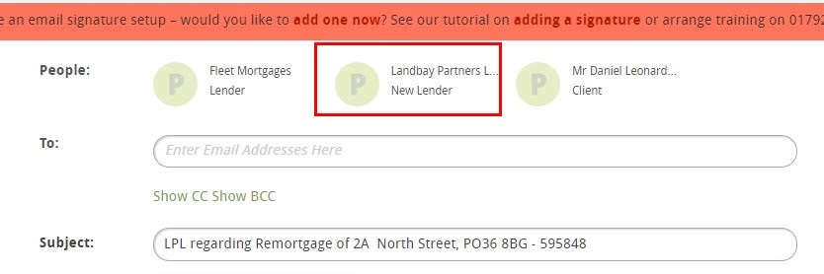

Step 16.5.B: Click on “Lender” in People for “Purchase case”.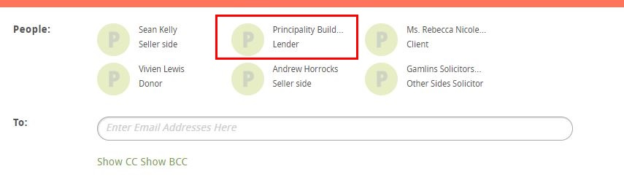

Step 16.6: Click on “Attach Other Documents”.

Step 16.7: Search for “COMPLETION:” then tick both the documents.



Step 16.8: Click on “Mark as Important” type the body and click on “Send”.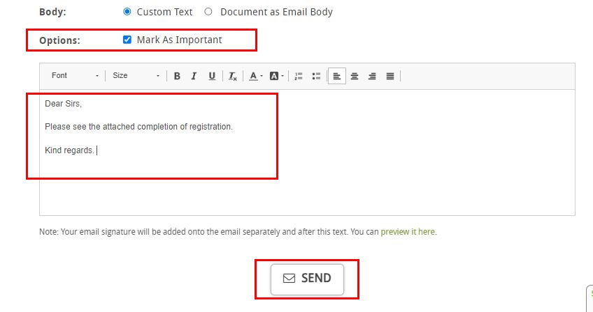

Step 16.9: Click on “Post Completion”.

Step 16.10: Click on “Attach Document”.

Step 16.11: Search “TID to client” click on “Attach Document”.

Step 16.12: Cross check the name and address of Client then click on “Send”.

Step 16.13: Click on “Client” in People (there might be multiple clients).

Step 16.14: Click on “Attach Other Documents”.

Step 16.15: Search for “COMPLETION:” then tick both the documents.



Step 16.16: Click on “Mark as Important” type the body and click on “Send”.

Step 16.17: Click on “Post Completion”.

Step 16.18: Click on “Mark as Done” for “Completed registration received and checked - names and registered charge correct”.

Step 16.19: Click on “Mark as Done” for “TID sent to client with any original documents if applicable”.

Step 16.20: Click on “Mark as Done” for “TID sent to Lender if applicable (update third party platform if applicable - Lender exchange/LMS)”. 

Step 16.21: Click on “Mark as Done” for “Reassigned to archive”.

Step 16.22: Click on “Add Note”.

Step 16.23: Click on “Mark as an Important” type the note on “Content” then click on “Save”.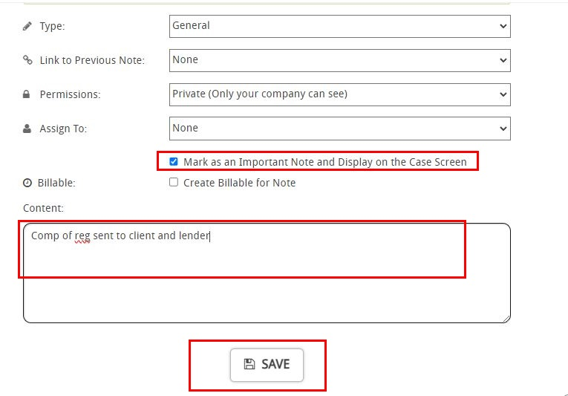

Step 16.24: Click on “Mark as Complete”. 

Step 16.25: Click on “OS1 Expiry Date”.

Step 16.26: Click on “Clear Date” and then “Save”.

Step 16.27: Click on “Setting”.



Step 16.28: Come to case Details Change “Fee Earner for case- Archive” and “Case Worker for case- Archive” then click on “Save”.

**Step 17: Sent to letter to OS (For purchase case only).**

Step 17.1: Click on “Post Completion”.

Step 17.2: Click on “Attach Document”.

Step 17.3: Search “Release from undertaking letter” click on “Attach Document”.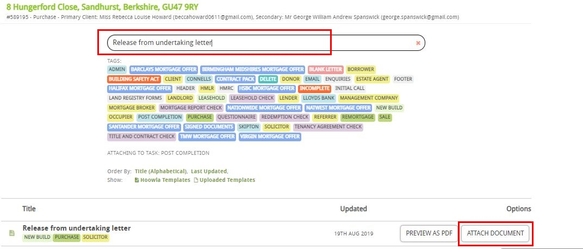

Step 17.4: Cross check the name and address of other side solicitor.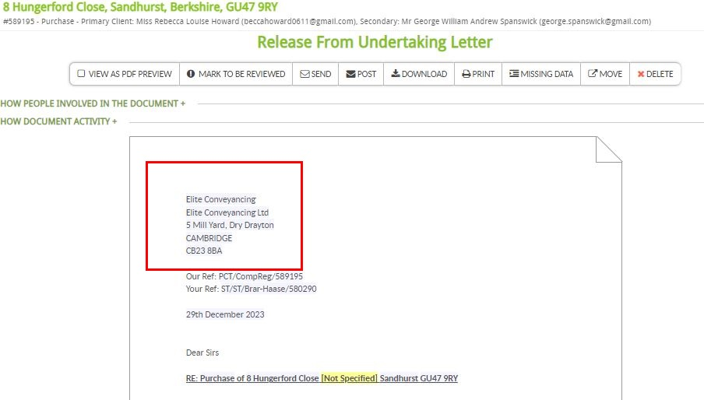

Step 17.5: Click on “Send”.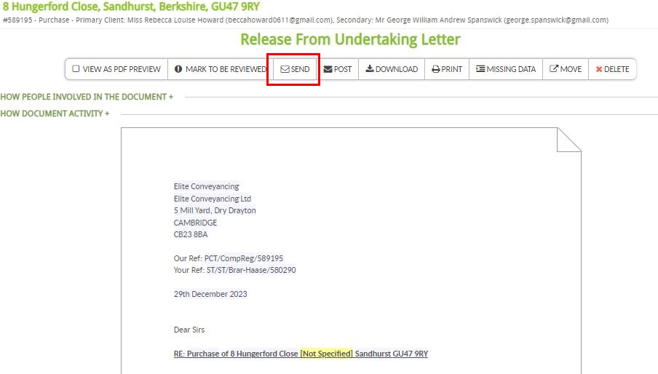

Step 17.6: Click on “Other Side Solicitor” in People.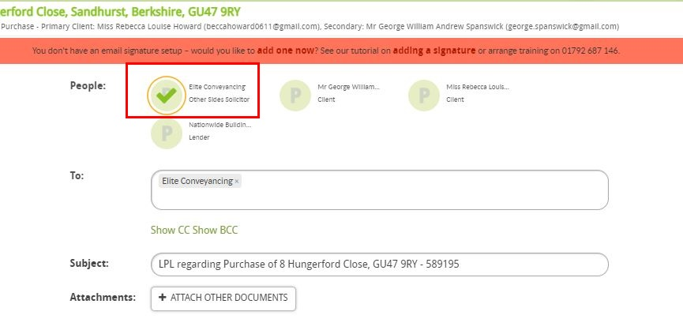

Step 17.7: Click on “Document as Email Body” Click on “Mark as Important” and then “Send”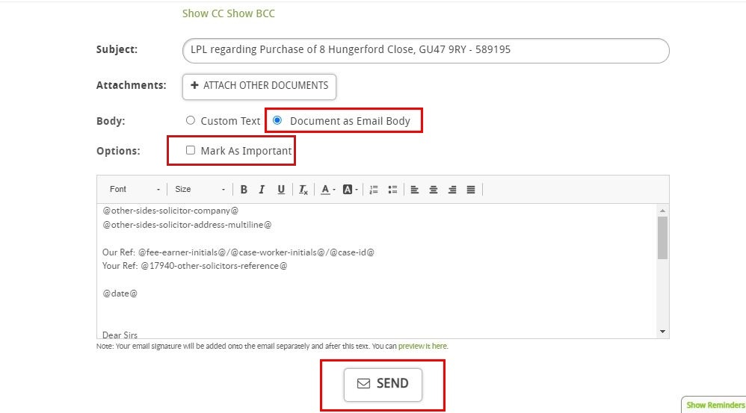

Step 17.8: Click on “Post Completion”.

Step 17.9: Click on “Mark as Done” for “Letter releasing buyers Solicitor from undertaking sent” (For Purchase case only).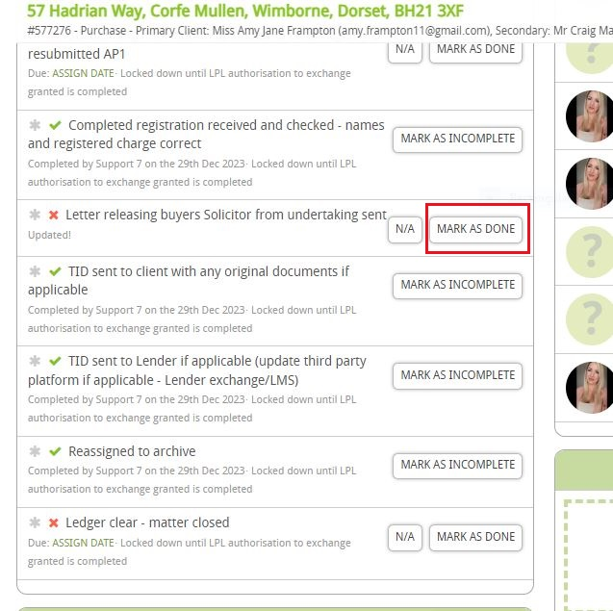

**Step 18: LMS STARS case**

Step 18.1: If LMS mention in the alert screen then extract the LMS Reference No.

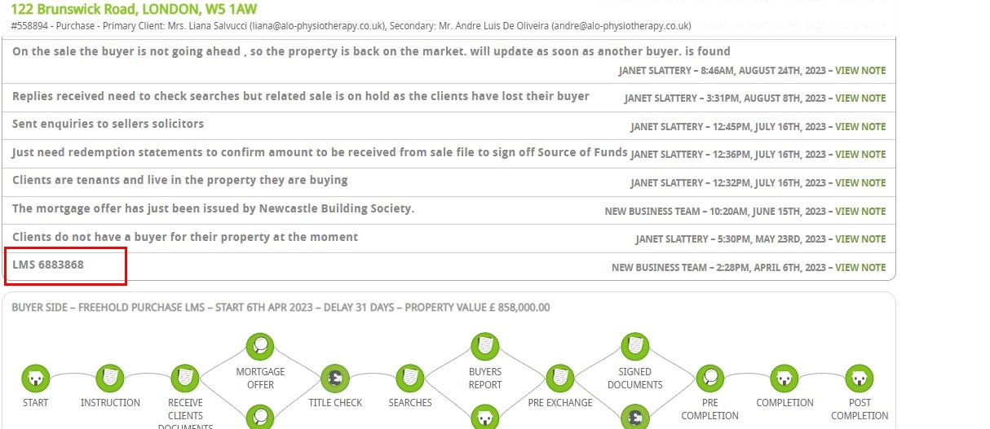

Step 18.2: Login to LMS STARS.

Step 18.3: Click on “Case dropdown” then on “Update Case”.

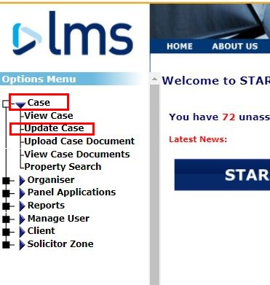

Step 18.4: Insert the reference then click “Search”.

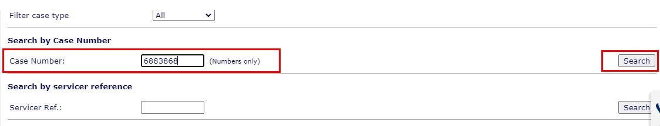

Step 18.5: Cross check the property address.

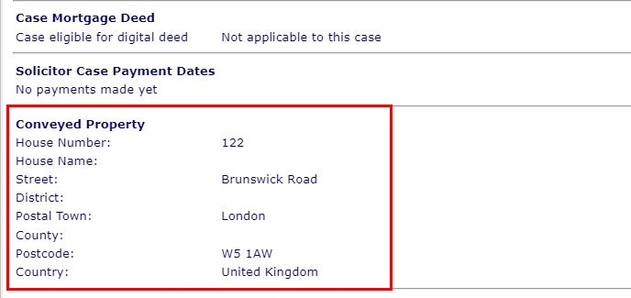

Step 18.6: Input the COMPLETION: 2-reg received date in the designated box then click on complete and ensure the rows above are also appropriately filled.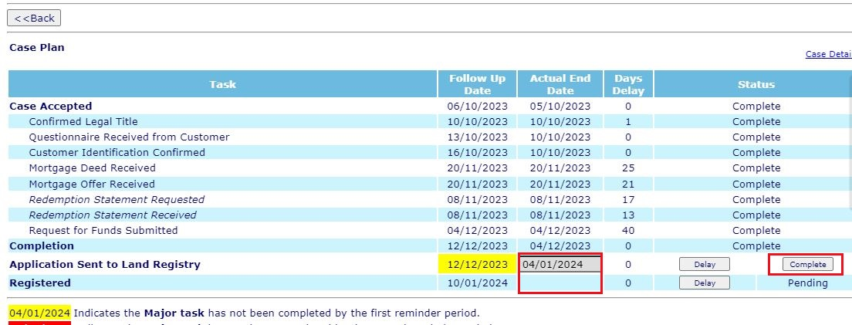

Step 18.6.A: If any delay reason asks in Note type “Application submitted” select “Customer - Chain” then click on “Submit”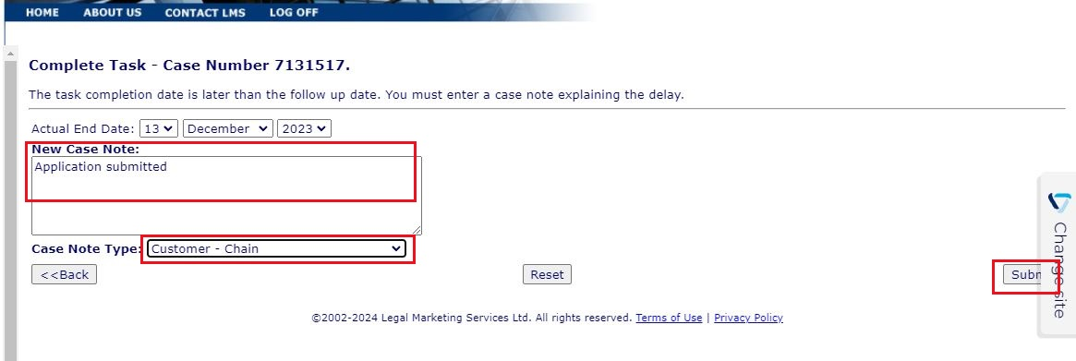

Step 18.6.B: COMPLETION: 2-reg received date.

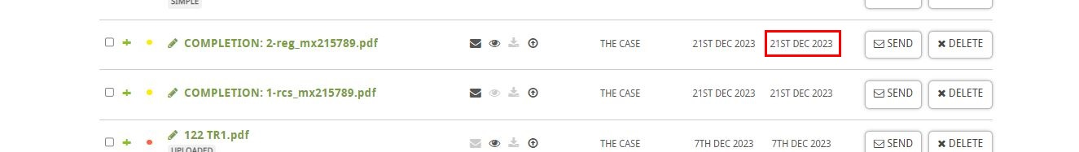

Step 18.7: Click on “Upload Case Documents” to upload COMPLETION: 2-reg document in LMS STARS.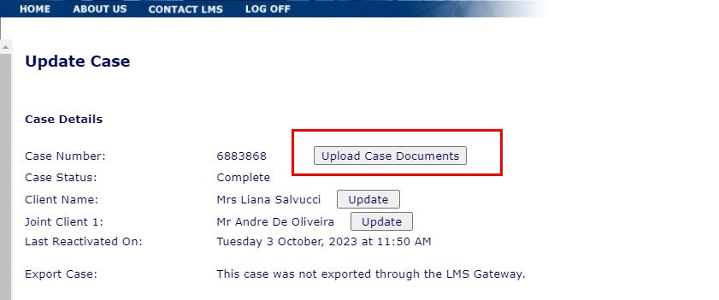

Step 18.8: Select the file type as “Title Information Document”.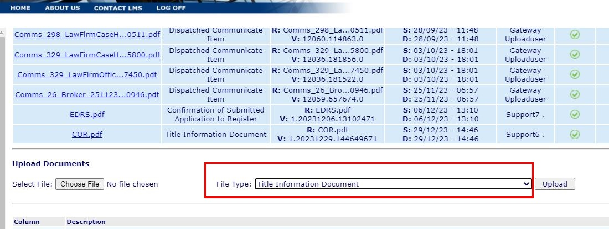

Step 18.9: Select the COMPLETION: 2-reg document then click on “Upload”.